GRADE 5
REVIEW UNIT 4
(From 6/4/2020 to 11/4/2020)

School: Long Hoa Primary School
Class: 5/______
Name: _______________________________________

1.Look and write
swim beach kayak surf windsurf sail waterski snorkel

 |  |  | 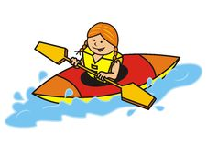
……………………. | ……………………. | ……………………. | …………………….
 | 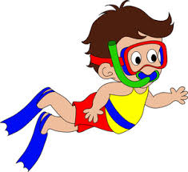 |  | 
……………………. | ……………………. | ……………………. | …………………….
2. Read and number
 |  | 
- He is surfing. | - He is waterskiing.
- She is kayaking. | - He is windsurfing.
- He is sailing. | - He is snorkeling.
3.Look and answer the questions
 |  | 
What are they doing ? | What are they doing ? | What is she doing ?
……………………………… | ……………………………… | ………………………………
 |  | 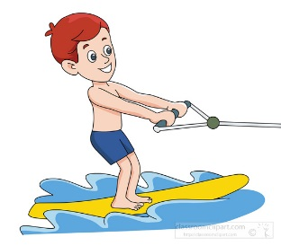
What are they doing ? | What is she doing ? | What is he doing ?
……………………………… | ……………………………… | ………………………………
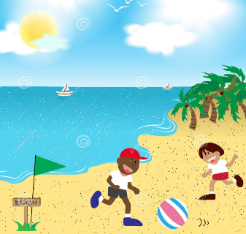 |  | 
What are they doing ? | What is she doing ? | What is he doing ?
……………………………… | ……………………………… | ………………………………
 | 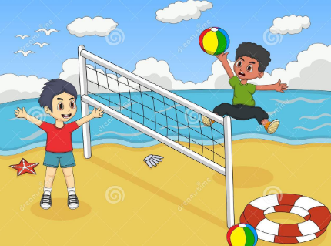 | 
What is he doing ? | What are they doing ? | What are they doing ?
……………………………… | ………………………………  The end | ………………………………

