School: Long Hoa Primary School
Class: 3/______
Name: _______________________________________
GRADE 3
REVIEW
(From 30/3/2020 to 3/4/2020)

Exercise 1: Look and write (Nhìn và viết)
dress | socks | T- shirt | pants
shoes | coat | hat | shorts
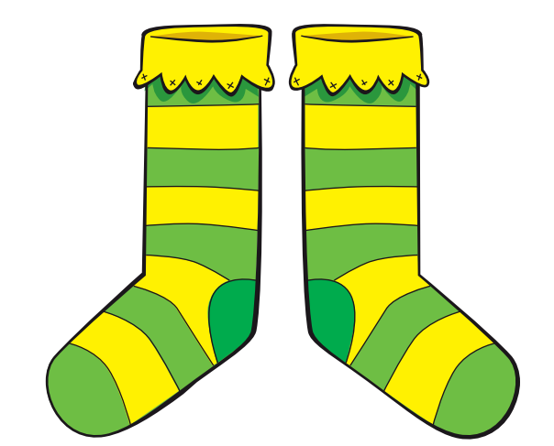 |  | 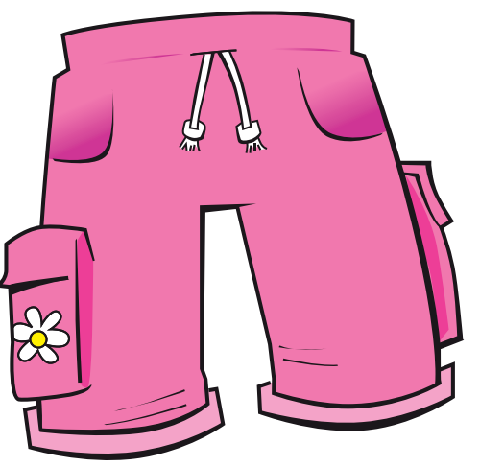 | 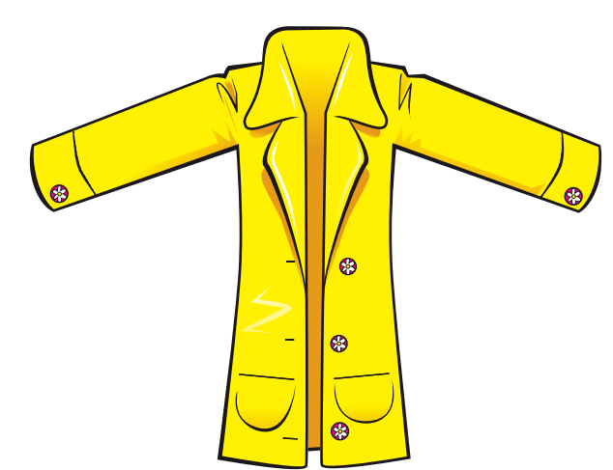
1. | 2. | 3. | 4.
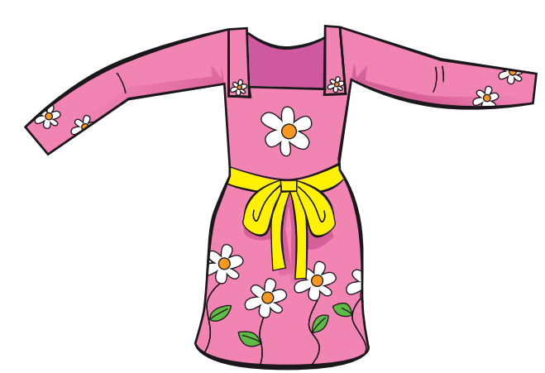 | 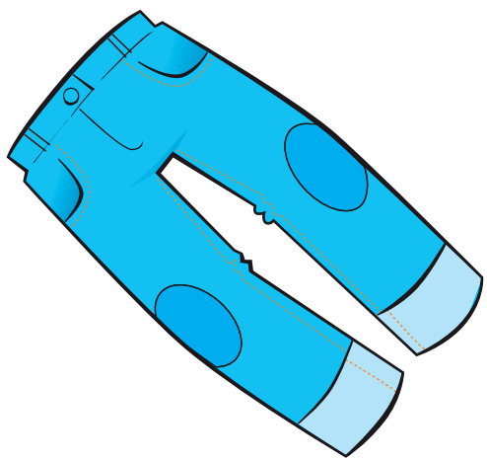 | 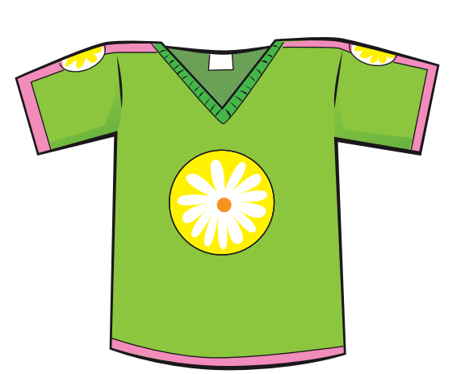 | 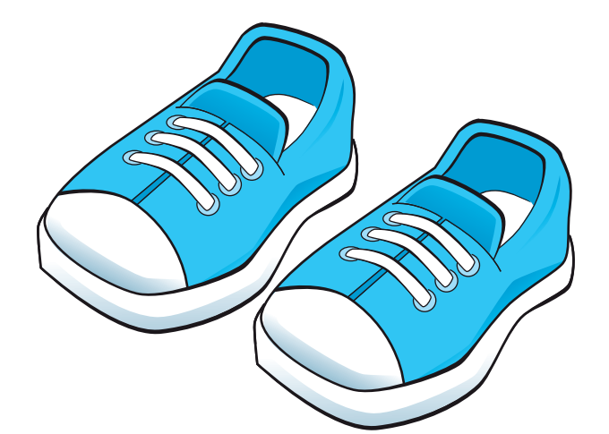
5. | 6. | 7. | 8.
Exercise 2: Look and write “his” or “her”(Nhìn và viết từ his hoặc her)
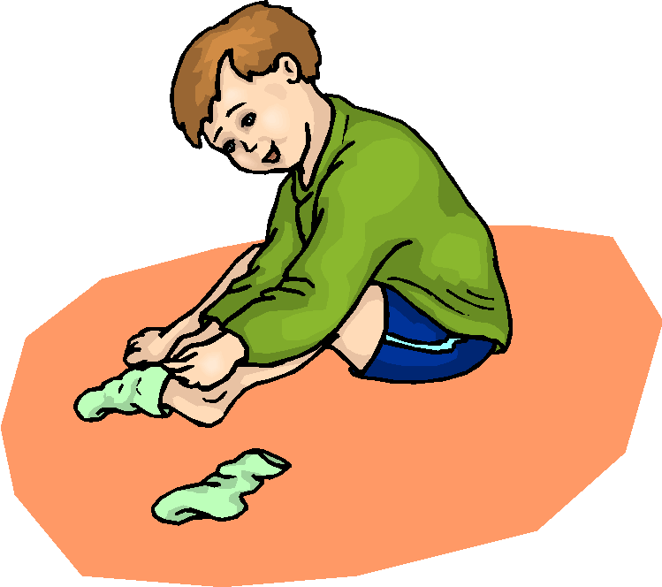 | 1. These are ……..…. socks. |  | 2. This is ……..…….coat.
 | 3. This is …….…….hat. | 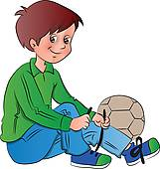 | 4. These are ……..….shoes.
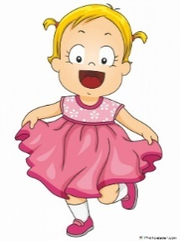 | 5. This is …….……. dress. | 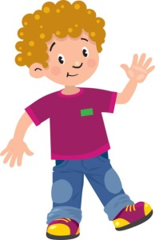 | 6. This is …………. T- shirt.

Exercise 3: Look and circle the correct answer (Khoanh tròn câu đúng)
1.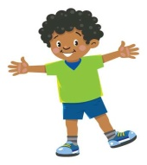 | a) This is his T- shirt.  b) This is his hat.  c) This is his coat. | 2. 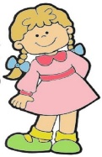 | a) These are her dress.  b) This is her dress.  c) This is her T-shirt.
3.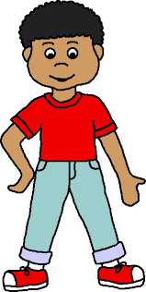 | a) These are his shoes.  b) These are his pants.  c) These are his socks. | 4.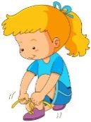 | a) This is her shoes.  b) These are her shoes.  c) These are her shorts.
5.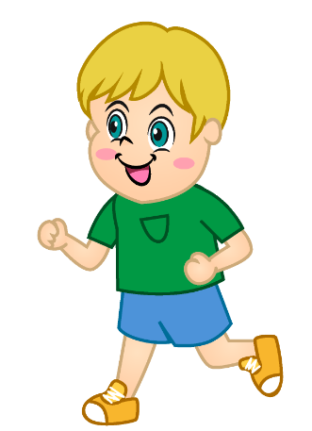 | a) These are his shorts.  b) These are his socks.  c) These are his shoes. | 6.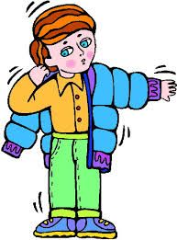 | a) This is his coat.  b) This is her coat.  c) This is his T-shirt.
Exercise 4: Circle the odd one out (Khoanh tròn từ khác loại)
1. | a) kite | b) teddy bear | c) train | d) bag
2. | a) T - shirt | b) coat | c) dress | d) slide
3. | a) in | b) under | c) on | d) These
4. | a) socks | b) shorts | c) tree | d) pants
5. | a) slide | b) bag | c) swing | d) swing
6. | a) teacher | b) nurse | c) school | d) doctor
7. | a) blue | b) green | c) black | d) tree
8. | a) hat | b) face | c) nose | d) hand

Exercise 5: Reorder the word to make the correct sentences. (Sắp xếp từ thành câu đúng)
- This – my – is – T - shirt.…………………………………………………………………………….
- are – These – shoes – my…………………………………………………………………………….
- Is – his – coat – this ?…………………………………………………………………………….
- Are – pants – these – his ?…………………………………………………………………………….
- These – shorts – are – his…………………………………………………………………………….
- Is – hat – this – hat ?…………………………………………………………………………….
- dress – Is – this – her ?…………………………………………………………………………….
8. socks – These – are – her…………………………………………………………………………….
Exercise 6: Look at the pictures and write (Nhìn tranh và viết câu trả lời)
 | Yes, they are |  | No , they aren’t
 | Yes, it is |  | No, it isn’t
1.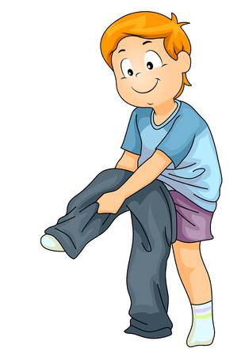 |  | Are these his socks ?  ………………………… |  | 5. 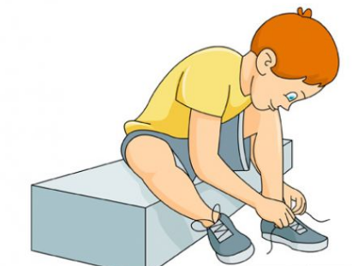 | Are these his shoes ?  …………………………
2.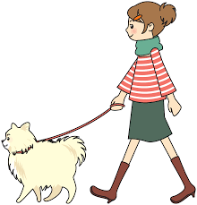 |  | - Is this her T- shirt ?  ………………………… |  | - 6. 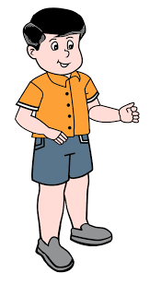 | Are these his pants?  …………………………
3. |  | Is this his coat ?  ………………………… |  | 7.  | - Is this her hat ?  - …………………………
4. |  | Is this her dress?  ………………………… |  | 8. | Is this his T-shirt ?  …………………………

Exercise 7: Look at the pictures and circle the right word.(Nhìn tranh và khoanh từ đúng)
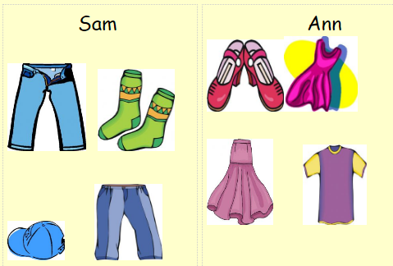 | 1. This is his / her hat.  2. These are his / her jeans.  3. These are his / her socks.  4. This is his / her skirt  5. This is his / her T-shirt.  6. These are his / her shoes.  7. This is his / her dress.  8. These are his / her pants.
Exercise 8: Fill the right possessive adjective in the blank (Điền tính từ sở hữu đúng vào chô trống)
my | his | your | her
- I am John. My name is John.
- He is Jason. ………………name is Jason.
- She is Mary. ………………name is Mary.
- What is ……………… name ? My name is Alex.
- She is my sister. ……………… name is Rosy.
- What is ……………… name ? Her name is Anna.
- What is his favorite color? ……………… favorite color is red.
- What is……………… favorite color? Her favorite color is green.
- What is ………………favorite toy ? Her favorite toy a doll.
- His name is Alex. ………………. T- shirt is red.
- ……………… name is Lisa. Her shoes are green.
- This is my brother. ………………name is Tony.
Exercise 9: Read and color.(Đọc và tô màu)
- Color his shoes brown. Color her shoes black.
- Color her hair brown. Color his hair yellow.
- Color her book green. Color his book orange.
- Color his toy duck red. Color her toy duck blue.
- Color his lunchbox purple. Color her lunchbox red.
- Color her hat purple. Draw his hat and color it blue.

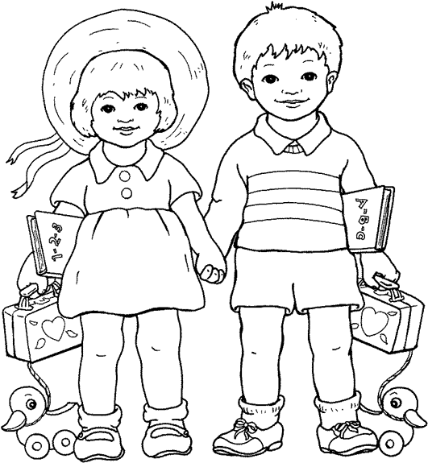
The end

