GRADE 4
REVIEW
(From 30/3/2020 to 3/4/2020)

School: Long Hoa Primary School
Class: 4/______
Name: _______________________________________

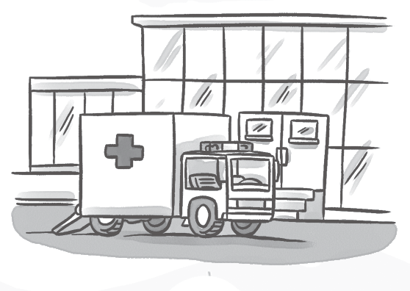

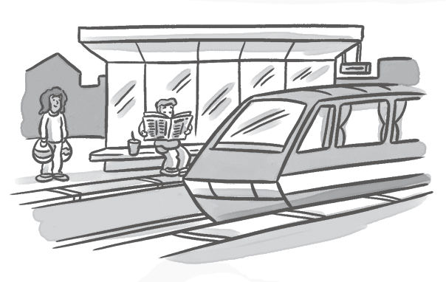
- Complete the words.

1 airport 2 z 3 h 4 s

Circle the correct word.



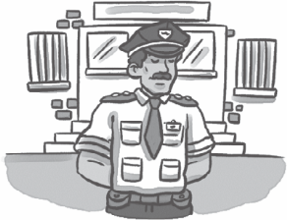
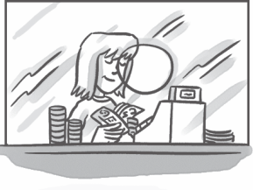
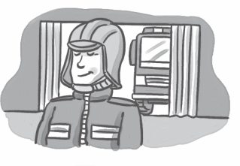
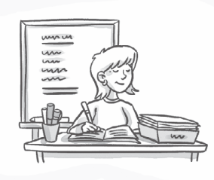


1
2
3
4
5
1 She works in a zoo / store. 2 He works in a police station / hospital.
3 She works in a bank / station. 4 He works in a store / fire station.
5 She works in a school / zoo.

Complete the sentences and match.





a
works in a store.
Where does your dad work?

b
_______your mom work
in a zoo?

c
your brother
at an airport?
, he does.
4
Where your
sister work?
d

No, she .

He in a bank.

4. Fill in the blanks.
a. Where does she work ? She _______________ in a school.
b. ___________ he work in a bank ? Yes , he does.
c. _____________ does he work ? He works in a zoo.
d. Does _________ work in a fire station ? Yes , he does.
e. Does he work in a police station ? No , he ________________.
f. Where do you work ? I ________________ in a store.
g. Does she work in a school ? ______________, she does .
h. _____________ he work in a zoo ? Yes , he does.
5. Find the mistakes and correct them.

a. Where do you works ? work
b. Do she work in a school ? Yes , she does. ________________________
c. Does he work in a shop ? No , he does. ________________________
d. Do you works in a zoo ? Yes , I do. ________________________
e. Does they work in a police station ? Yes , they do. ________________________
f. When does she work ? She works in a store . ________________________
g. Where do you work ? I works in a hospital. ________________________
The end

